REFRIGERATION
REFRIGERATION: It’s a process of creating or maintaining lower temperature than surroundings.
CLAUSIUS STATEMENT: It’s impossible to construct a device which operates on a cycle and transferring heat from low temperature body to high temperature body without any external work input.
REFRIGERATOR: Refrigerator is a device which must operate on cyclic process and creates and maintain low temperature than surroundings continuously by some external work input. ${COP}_{R}={Q_{2}}/W$
REFRIGERATION EFFECT:
It’s the amount of heat which is to be extracted from storage space in order to maintain at lower temperature.$Q_{2}$
HEAT PUMP: It’s device which must operate on cyclic process and creates and maintain high temperature than surroundings continuously by some external work input.${COP}_{HP}={Q_{1}}/W$
REFRIGERATION CAPACITY:$RC (KW)=\dot{m}Q_{2}$
UNIT OF REFRIGERATION
$$1 tonne (British)=1000 kg$$ | $$1 ton \left(US\right)=907 kg=2000 Pounds$$
1 TON OF REFRIGERATION: It is the amount of heat which is to be extracted from 1 ton of water at $0 °C$ in order to convert into 1 ton of ice at $0 °C$ in 24 hours. $1 ton=3.5 KW$
REFRIGERANT: these are the heat carrying medium in a refrigeration system.
- Primary Refrigerant: These are refrigerant upon which compression and expansion take place and undergoes a cycle to produce lower temperature. E.g. NH3, R12, R22, R134a, Etc…
- Secondary Refrigerant: These are refrigerant upon which are first cooled by the primary refrigerant and then used for cooling at the desired place. E.g. Water, Air, Etc…
TD Cycles
Power Cycles |  | Refrigeration Cycles
Vapour Power Cycle | Gas Power Cycle | Gas Refrigeration Cycles | Vapour Refrigeration Cycles
Rankine cycle | Gas Turbine | Reversed Carnot (Ideal) | Ideal Carnot | VCR | VAR
In vapour cycle Working fluid undergoes Phase change.
IDEAL/ CARNOT REFRIGERATION CYCLE:
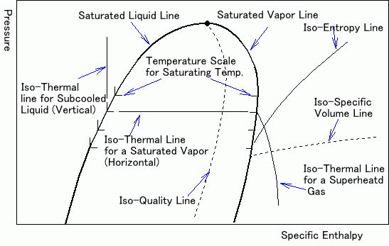 |  |  | 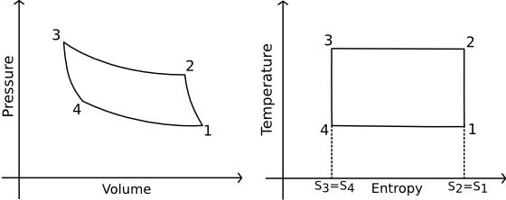
$$Q_{l}=h_{1}-h_{4}$$ |  | $$Q_{h}=h_{2}-h_{3}$$ | $$W_{in}=W_{C}-W_{exp}=\left(h_{2}-h_{1}\right)-\left(h_{3}-h_{4}\right)$$
$${COP}_{R}=\frac{Q_{l}}{W_{in}}=\frac{T_{l}}{T_{h}-T_{l}}=\frac{CE}{P_{in}}$$ |  |  | $${COP}_{HP}=\frac{Q_{h}}{W_{in}}=\frac{T_{h}}{T_{h}-T_{l}}=\frac{HE}{P_{in}}$$
$$W_{in R}=\left[\frac{T_{h}-T_{l}}{T_{l}}\right]Q_{l}=\left[\frac{T_{h}-T_{l}}{T_{l}}\right]\left(h_{1}-h_{4}\right)$$ |  |  | $$W_{in HP}=\left[\frac{T_{h}-T_{l}}{T_{h}}\right]Q_{h}=\left[\frac{T_{h}-T_{l}}{T_{h}}\right]\left(h_{2}-h_{3}\right)$$
$$T_{h}=T_{sat}@P_{h}$$ |  | $$T_{l}=T_{sat}@P_{l}$$ | $$h_{2}=h_{g}@P_{h}$$ | $$h_{3}=h_{f}@P_{h}$$
$$Capacity of Ref.=\dot{m}Q_{l}=\dot{m}\left(h_{1}-h_{4}\right)$$ |  |  | $$Capacity of Heating=\dot{m}Q_{h}=\dot{m}\left(h_{2}-h_{3}\right)$$
$$P_{in}=\dot{m}\left[W_{in}\right]=\dot{m}\left[\left(h_{2}-h_{1}\right)-\left(h_{3}-h_{4}\right)\right]$$
VAPOUR COMPRESSION REFRIGERATION SYSTEM: | 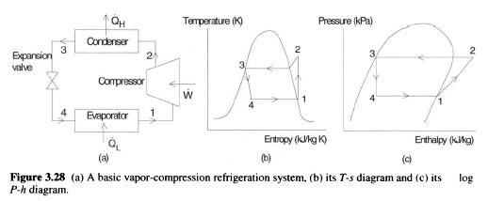
VAPOUR COMPRESSION REFRIGERATION SYSTEM:
1-2: Reversible Adiabatic Compression,  $$h_{1}=h_{g}@P_{l} (At Evaporation Pressure)$$  $$h_{2}=h_{sup}@P_{h} \& T_{sup}(At Condention Pressure)$$  $$Or h_{2}=h_{g}@P_{h}+C_{P vap}(T_{sup}-T_{sat})$$  $$Or s_{1}=s_{g}@P_{l}=s_{2}$$  From property table, $h_{2}=h_{sup}@P_{h} \& s_{2}$  $$Or w_{in}=\left[\frac{n}{n-1}\right]\left(P_{2}v_{2}-P_{1}v_{1}\right)$$  From the 1st Law, $h_{2}=h_{1}+w_{in}$ | 2-3: Constant Pressure heat Rejection,  $$h_{3}=h_{f}@P_{h}(At Condention Pressure)$$  From the 1st Law, $q_{R}=h_{2}-h_{3}$  3-4: Throttling process (Reversible Adiabatic Expansion),  From the 1st Law, $h_{4}=h_{3}$  4-1: Constant Pressure heat Addition,  From the 1st Law, $q_{in}=h_{1}-h_{4}=Ref. Eff.$  $${COP}_{R}=\frac{q_{in}}{w_{in}}=\frac{h_{1}-h_{4}}{h_{2}-h_{1}}=\frac{h_{1}-h_{3}}{h_{2}-h_{1}}$$
$$Capacity of Refrigeration=\dot{m}q_{in}=\dot{m}\left(h_{1}-h_{4}\right)$$ | $$Capacity of Heating=\dot{m}q_{out}=\dot{m}\left(h_{2}-h_{3}\right)$$
$$P_{in}=\dot{m}\left[w_{in}\right]=\dot{m}\left(h_{2}-h_{1}\right)$$
PERFORMANCE PARAMETER FOR VCR:
Volumetric Efficiency of reciprocating compressor | $$η_{vol.}=1-C\left[{\left(r_{p}\right)}^{1/n}-1\right]$$

DECREASING IN EVAPORATOR PRESSURE |  | INCREASE IN CONDENSER PRESSURE
- Ref. Effect decreases  - $w_{in}$ increases  - $COP$ Decreases  - Volumetric Efficiency decreases  - Evaporator pressure depends on desired lower temperature. |  | - Ref. Effect decreases  - $w_{in}$ increases  - $COP$ Decreases  - Volumetric Efficiency decreases  - Condenser pressure depends on surrounding temperature.
NOTE: The condenser pressure should be in such a way that corresponding saturation temperature must be grater than surrounding temperature.
SUPERHEATING |  | SUBCOOLING
- Ref. Effect increases  - $w_{in}$ increases  - $COP$ may increases or decreases depends on refrigerant. In case of NH3 it decreases and In case of R12 it increases.  - Volumetric Efficiency remains same |  | - Ref. Effect increases  - $w_{in}$ remains same  - $COP$ may increases.  - Volumetric Efficiency remains same
SUPERHEATING & SUBCOOLING
- Ref. Effect increases.  - $w_{in}$ increases.  - $COP$ may increases.  - Volumetric Efficiency remains same | 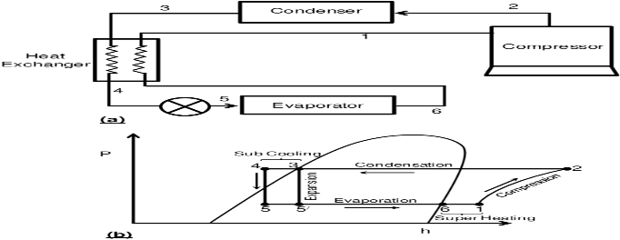

USE OF FLASH CHAMBER | USE OF ACCUMULATION
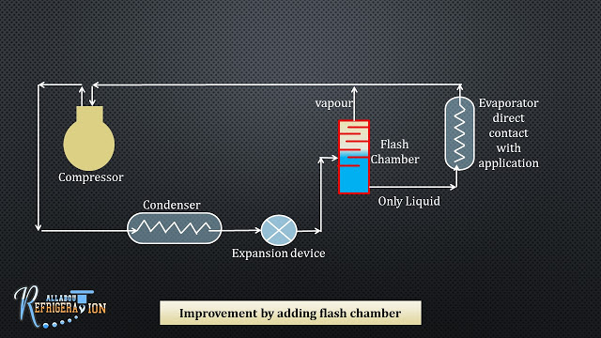 | 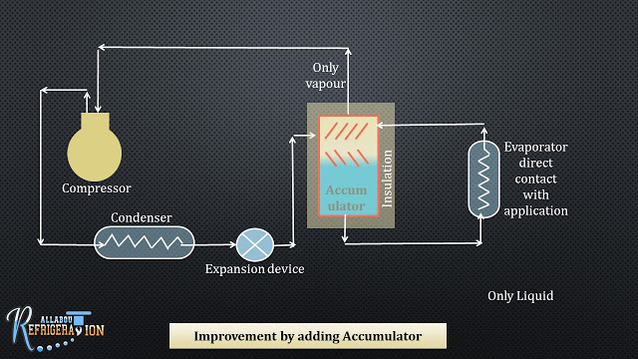
Size of Evaporator Reduce | Size of Evaporator Reduce as well as pump is more safe.

CASCADE REFRIGERATION
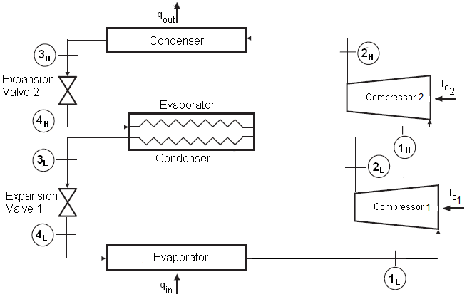 | 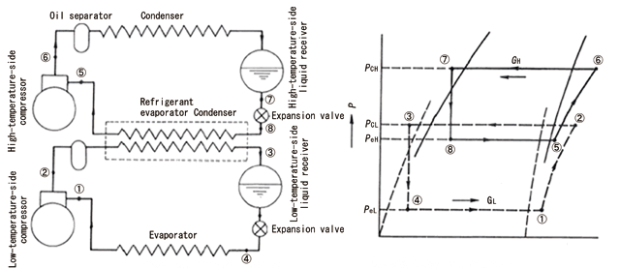
For Cascaded System, ${COP}_{Cascade}= {\left[{COP}_{1}{COP}_{2}\right]}/{\left[1+{COP}_{1}+{COP}_{2}\right]}$
DESIGNATION OF REFRIGERANT ($C_{m}H_{n}F_{p}{Cl}_{q}$)
CASE-I: SATURATED HYDROCARBON | CASE-II: UNSATURATED HYDROCARBON
$$R-\left(m-1\right)\left(n+1\right)p$$  $$Where, n+p+q=2m+2$$ | $$R-1\left(m-1\right)\left(n+1\right)p$$  $$Where, n+p+q=2m$$
CASE-III: INORGANIC REFRIGERANT
$$R-(700+Molecular Weight)$$ | E.g. NH3 = R-717, CO2 = R-744, Air = R-729, SO2=R-764
- Cl atom contain in chemical formula is responsible for the depletion of ozone layer.
- If chemical formula does not contain Cl then it’s eco-friendly refrigerant. E.g. R-134a is eco-friendly refrigerant.
- The F atom in the molecules of refrigerant make it physiologically more favourable.
- The H atom in molecules impacts degree of flammability.
VAPOUR ABSORPTION REFRIGERATION SYSTEM: Useful when capacity system is high. Work with low grade energy. So, it’s useful when high amount of waste energy available.
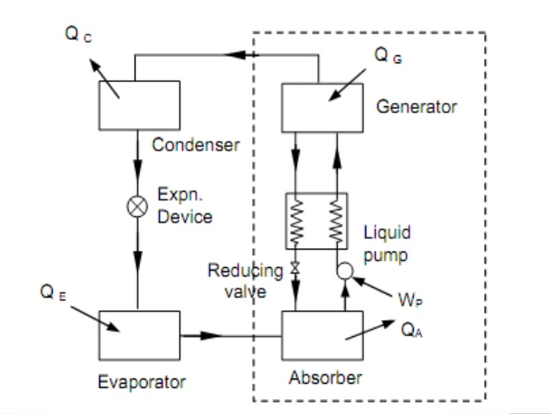 | $$T_{G}$$ $$T_{G}$$ $$T_{o}$$  $$Q_{G}↓$$ $$Q_{G}↓$$ $$Q_{2}↑$$  $$VAR$$ $$→Q_{o}-Q_{a}$$ $$T_{o}$$ $$HE$$ $$→W→$$ $$Ref.$$  $$Q_{e}↑$$ $$Q_{1}↓$$ $$Q_{e}↑$$  $$T_{e}$$ $$T_{o}$$ $$T_{e}$$  Where, $Q_{e}$ = Energy absorbe by evaporator,  $Q_{G}=$ Energy Supplied for heating,  $Q_{a}=$ Energy Rejected from absorber chamber,  $Q_{o}=$ Energy Rejected from Condensor.  According to 1st Law, $\sum{Q}=\sum{W}$  $$Q_{e}+Q_{G}-Q_{a}-Q_{o}=-W_{P}$$
According to 2nd Law, $\oint{\frac{dQ}{T}}≤0$,  $$\frac{Q_{G}}{T_{G}}+\frac{Q_{e}}{T_{e}}-\frac{Q_{o}+Q_{a}}{T_{0}}≤0⇒\frac{Q_{e}}{Q_{G}}≤\left(\frac{T_{G}-T_{o}}{T_{G}}\right)\left(\frac{T_{e}}{T_{o}-T_{e}}\right)$$ | $$∴{\left({COP}_{R}\right)}_{max}=\frac{Q_{e}}{Q_{G}}=\left(\frac{T_{G}-T_{o}}{T_{G}}\right)\left(\frac{T_{e}}{T_{o}-T_{e}}\right)$$
GAS REFRIGERATION SYSTEM (AIR REFRIGERATION SYSTEM):
- Air is used as refrigerant which is treated as ideal gas (No phase change).
- It’s based on reversed Brayton cycle also known as “Bell Coleman Cycle”
BELL COLEMAN CYCLE:
- It’s used for aircraft refrigeration system because of it’s low weight per ton of refrigeration.
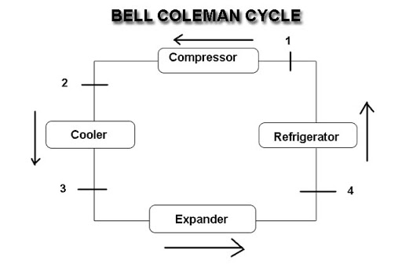 | 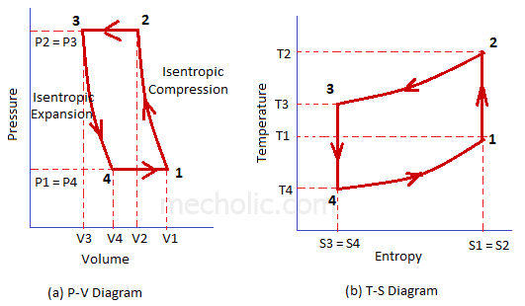
- If any ideal gas undergoes throttling process, there will be no temperature difference after throttling process. Hence, we can’t use throttling process in this cycle.
- Isentropic expansion gives some work whereas isenthalpic expansion (Throttling) is not giving work. But in actual case, isentropic work is really very small, hence the enthalpy remains almost same hence, COP also remains almost same.

1-2: Rev. Adiabatic Compression | 2-3: Constant Pressure heat Rejection.
From 1st Law,  $$W_{c}=h_{2}-h_{1}=C_{P}dT=C_{P}(T_{2}-T_{1})(For Ideal Gas)$$ | From 1st Law,  $$q_{h}=h_{2}-h_{3}=C_{P}dT=C_{P}\left(T_{2}-T_{3}\right)\left(For Ideal Gas\right)$$
3-4: Rev. Adiabatic Expansion | 4-1: Constant Pressure heat Addition
From 1st Law,  $$W_{e}=h_{3}-h_{4}=C_{P}dT=C_{P}\left(T_{3}-T_{4}\right)\left(For Ideal Gas\right)$$ | From 1st Law,  $$q_{l}=h_{1}-h_{4}=C_{P}dT=C_{P}\left(T_{1}-T_{4}\right)\left(For Ideal Gas\right)$$
$$W_{net}=W_{c}-W_{e}=C_{P}\left(T_{2}-T_{1}\right)-C_{P}\left(T_{3}-T_{4}\right)=C_{P}\left(T_{2}-T_{1}-T_{3}+T_{4}\right)$$
$${COP}_{R}=\frac{Q_{l}}{W_{in}}=\frac{T_{1}-T_{4}}{T_{2}-T_{1}-T_{3}+T_{4}}=\frac{1}{\frac{T_{2}-T_{3}}{T_{1}-T_{4}}-1}=\frac{1}{{\left(r_{p}\right)}^{\frac{γ-1}{γ}}-1}$$ |  | $$r_{p}=\frac{P_{h}}{P_{l}}=\frac{P_{2}}{P_{1}}=\frac{P_{3}}{P_{4}}={\left[\frac{T_{2}}{T_{1}}\right]}^{\frac{γ}{γ-1}}={\left[\frac{T_{3}}{T_{4}}\right]}^{\frac{γ}{γ-1}}$$
$${\left(r_{p}\right)}_{min}=1$$ |  | At ${\left(r_{p}\right)}_{min}=1$, ${COP}_{R}=∞$
$$P_{in}=\dot{m}C_{P}\left[\left(T_{2}-T_{1}\right)-\left(T_{3}-T_{4}\right)\right]$$ |  | $$Capacity of R=\dot{m}C_{P}\left(T_{1}-T_{4}\right)$$
REQUIREMENT OF REFRIGERATION OF AIRCRAFT:
- Pressure and Temperature are very low at higher altitude.
- Due to ramming effect pressure and temperature increases because of high velocity of air craft.
- Instruments generates heat and human passengers also generate heat.
- Why Air Refrigeration only not other? Cheap and easily available and no leakage issue. Their weight per ton is low. And no other additional instrument required due to engine system used in refrigeration. ${COP}_{R AirCraft}≈0.4$
TYPES OF AIR CRAFT REFRIGERATION SYSTEM
Simple system | Boot Strap System
It’s good for ground cooling. & Use At low Speed. | Used in Transport type aircraft to get more lower temp.
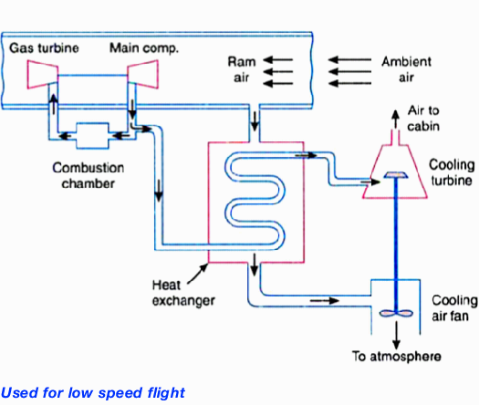 | 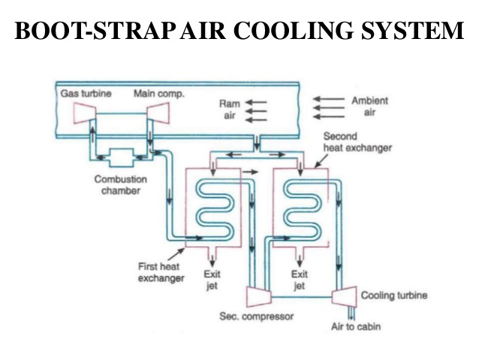
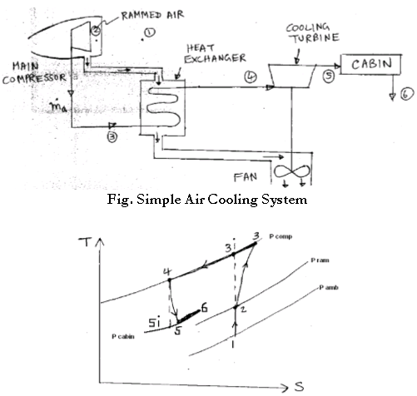 | 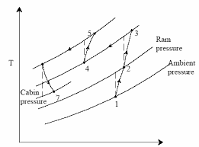
 | Can’t use for ground application.
Regenerative System | Reduced Ambient System
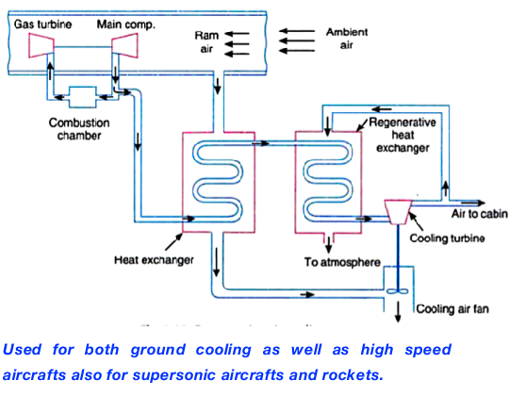 | 